Art image classification using convolution neural networks

Taranjit Singh

Department of computer science

Chandigarh college of engineering and technology

Roll no CO15357

**ABSTRACT**

Art image classification is a method to recognize a sort of workmanship present in a given image whether it is drawing, painting and so on. Different machine learning approaches are utilized in this undertaking. I utilized python syntax for composing code. I utilized Keras as a system, which is an abnormal state neural system API written in Python. I additionally utilized programming library Tensorflow. As an advancement domain I utilized the Anaconda Navigator .For system preparing and testing I utilized a dataset of photographs artistic creations anddrawing downloaded from kaggle. The model includes completely associated lays.

*Keyword classification, convolution neural network, deep learning, machine learning, Keras etc.*

**INTRODUCTION**

[1] Machine learning has been gaining momentum over last decades: self-driving cars, efficient web search, speech and image recognition. The successful results gradually propagate into our daily live. **Machine learning** is a class of artificial intelligence methods, which allows the computer to operate in a self-learning mode, without being explicitly programmed. It is a very interesting and complex topic, which could drive the future of technology. [2] Despite the signiﬁcant amount of research done in this area, most of the work revolves

around benchmark datasets, consisting of fairly high quality images. In real-life applications, however, we are of- combination of these factors, to name a few. Further- more, their nature is not always known a priori. Thus, in many cases resilience to previously unmet types of distortions in necessary. The impact of image quality on performance of computer vision algorithms is of-

ten overlooked, which may in turn lead to unrealistic expectations in practical applications.

**MOTIVATION**

Sometimes a work is done too accurately that it is difficult to differentiate to different types of art whether it is painting or drawing. This model will help us to solve this problem. Also I wanted to learn how classification occurs using neural network. Hence from here I learnt much about same

from here I learnt much about same

**CONTRIBUTION**

In the proposed model, we utilize deep convolution neural system having various 1d convolution layers for preparing and testing of data. The model accomplishes a general exactness of 98.03%.

**RELATED WORK**

Creative work has attracted much attention in the AI community, maybe because of the philosophical questions that it raises or because of the potential applications. As a result, a number of publications have discussed the problem of art generation and art style recognition. nition in several artistic domains such as visual arts, drawing,paintings,etc.[3] In the domain of visual art generation, Gatys et al. (2015) were able to build a model of a specific painting style and then transfer it to non-artistic photographs1 . From a technical perspective, art generation is not very different from art style recognition: in both cases, the first step is to accurately model one or several artistic styles. Gatys et al. (2015) started by training a deep VGG net (Simonyan and Zisserman, 2014) with a large number of pictures from a given artistic style. Then they generated an image that compromised the matching of the style with the matching of the original input image. However, one important difference with the problem of art style recognition, is that the model needs to separate style from content as much as possible in order to successfully transfer the style to a new content. In style recognition, we use the description of the content as an additional feature to recognize the style (e.g., a person is more likely to appear in an impressionist painting than in an abstract painting). The problem of art style recognition has been directly addressed by a number of other publications. The techniques proposed usually work either with pre-computed features such as color histograms etc. spacial organisation and lines descriptions (Florea et al., 2016; Liu et al., 2015), or directly with the image itself (Saleh and Elgammal, 2015; Tan et al., 2016). Liu et al. (2015) have been able to achieve good results using pre-computed features using multi-task

dictionary across several artists having painted with the same style. Although working with pre-computed features can be useful to better understand the behavior of the classifier, the resulting classifiers do not generally achieve the best accuracy.

**PROPOSED SCHEME**

Input image is fed to the CNN mode from which features are extracted. Then pooling is applied followed by flattening.

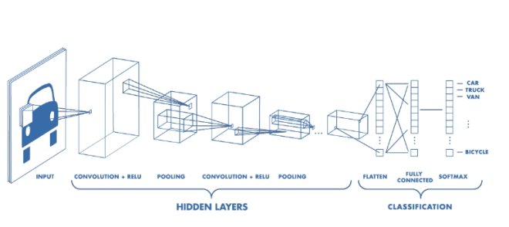

learning and dictionary learning. To achieve this result, they propose to discover a style-specific dictionary by jointly learning an artist-specific

Flattening steps converts the image into 1-D vector which is then input to ANN. The following block diagram shows the architecture of model

ALGORITHM USED

Convolution neural systems are most appropriate for dataset that comprises of pictures. CNN are profound learning models for PC vision to classify some pictures a few photos or even a few pictures and a few recordings.

CNN comprises of ANN as its subpart and utilize batch gradient descent. The pictures are taken in bunches and weights are refreshed according to the loss function. A weight is found past which the loss can't be minimized. At that point this weight is backpropgated with the utilization of backpropagation algorithm.

The model comprises of the accompanying steps:

• **Convolution**: The input to this progression is a picture. With the assistance of some element finders

the models extricate some features and convert the picture into set of feature maps.

thick neural system in which every node in a layer is associated with every node in next and previous layers.

.

• **Flattening**: In this progression the majority of the element maps are changed over into 1-D input vector which is then fed to ANN.

**• Pooling**: A window of an explicit size is slided over feature maps pixels and most extreme value from the pixels in windows is chosen. Inputs to this progression are highlight maps on which filters are

thick neural system in which every node in a layer is associated with every node in next and previous layers.

**DISCUSSION**

**Tensorflow** backend is utilized. It enables us to perform superior numerical calculation. Keras is a neural system API which is written in python. It gives different modules to create neural systems. Following modules

have been utilized in this model:

• **Sequential**: This module gives a direct heap of layers. It permits to include layers grouping by succession.

• **Conv2D**: It enables us to change over the input picture to features maps.

• **MaxPooling2D** It is utilized to apply max pooling task on the element maps and in this manner decrease the extent of information by protecting the features.

• **Flatten**: It changes over the pooled feature maps into 1-D vector. • **Dense**: It enables us to make a

• I**mageDataGenerator**: This is utilized in Image growth. It builds the dataset. Close to above modules following two functions are utilized as activation function:

• **Relu**: Rectified linear unit work is utilized in hidden layers and in addition convolution venture to guarantee that there are no negative values.

• **Softmax**: Softmax function is utilized to give of a probability of the information having a place with one of the class labels. In light of the probabilities the output values are displayed after one hot encoding.

**DATASET**:

The dataset comprises of 2000 pictures of blooms having a place with 2 classes. The informational collection is isolated into two sections. The initial segment comprises of the training set which has 2000 pictures. The second part comprises of 500 pictures which is training set. Since the dataset is less we utilize the Image Data Generator class to apply growth to the info pictures and to build our dataset.

**RESULTS**

Following outcomes were watched:

**1**. The model obtained an accuracy of 94.27 percent on the training data when training dataset had 2000 images, 2 convolution layers dropout was used. See Figure 2 .

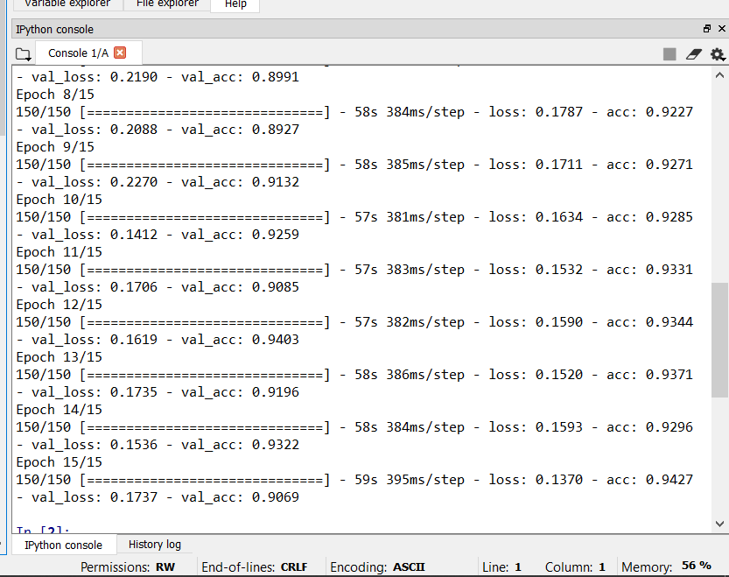

Figure 2

**2**. The model obtained an accuracy of 95.44 percent on the training data when training dataset had 2000 images, 2 convolution layers and no dropout were used.See Figure 3 .

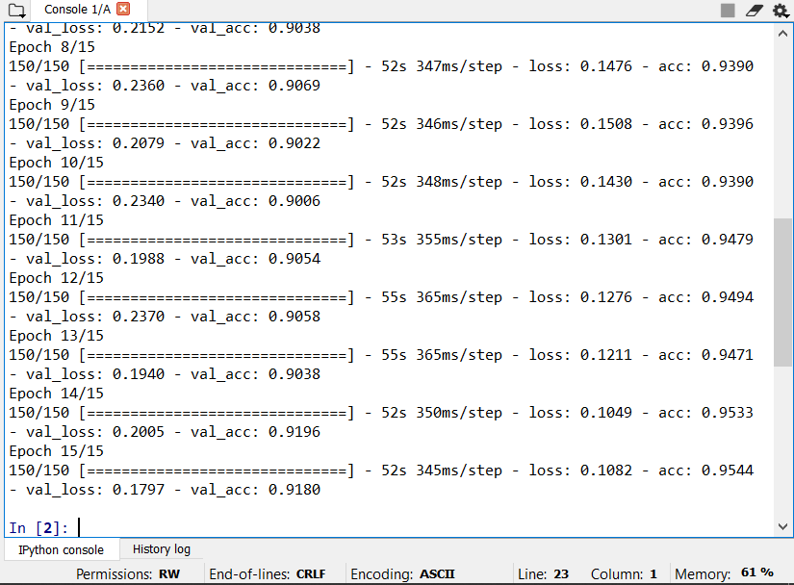

Figure 3

**3**.The model obtained an accuracy of 95.40 percent on the training data , when training dataset had 2000 images, 1 convolution layer and dropout was used. See Figure 4 .

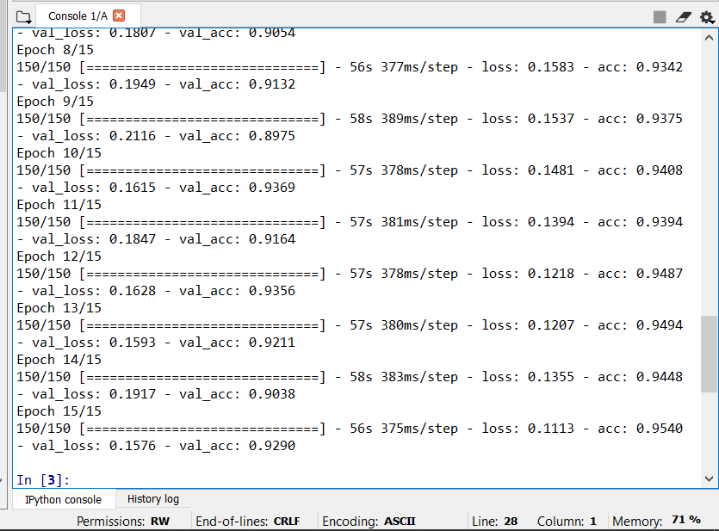

Figure 4

**Following points were finished up from our work:**

• Adding a convolution layer may increment or decline the exactness of CNN to some degree.

• More is the dataset more is the exactness. Be that as it may, this also is consistent with some size of dataset.

Dataset cannot be too large.

• Keras make it simple to consequently include classes the premise of structure of training dataset folder.

• Softmax function should be utilized when output has multiple classes.

• Image expansion builds the extent of input dataset and hence

**REFERENCES**

# [1] **Image Classification with Convolutional Neural Networks**

# **url https://medium.com/@ksusorokina/image-classification-with-convolutional-neural-networks-496815db12a8**

**[2]** Image Recognition with Deep Neural Networks in Presence of Noise - Dealing with

and Taking Advantage of Distortion https://www.researchgate.net/publication/319238759_Image_recognition_with_deep_neural_networks_in_presence_of_noise_-_Dealing_with_and_taking_advantage_of_distortions

# [3] A Neural Algorithm of Artistic Style url https://arxiv.org/abs/1508.06576

**[4]** Art Painting Identification using convolutional neural network.

url <https://www.ripublication.com/ijaer17/ijaerv12n4_17.pdf>

# [5] Image Classification Using Convolutional Neural Networks. <https://www.researchgate.net/publication/275257620_Image_Classification_Using_Convolutional_Neural_Networks>

# [6] Nils back Andrew. Zisserman, "A Visual Vocabulary for Flower Classification", Computer Vision and Pattern Recognition IEEE Computer Society Conference on, vol. 2, 2006.

**[7]** Heng-Nian Qi, Jian-Gang Yang. Sawtooth Feature Extraction of Leaf Edge Based on Support Vector Machine. IEEE. 2003

**[8]** Shulin Dave, Ken Runtz, Image Processing Methods for Identifying Species of Plants. IEEE CAT. 1995

**[9]** Ash A, Ellis B, Hickey L J, Johnson K, Wilf P, Wing S, Manual of Leaf Architecture,

# [10] A Survey on Image Classification and Activity Recognition using Deep Convolutional Neural Network Architecture. Ninth international conference on advanced computing (ICoAC 2017), at Anna, University, Chennai.

# [11] Image Classification Using Convolutional Neural Networks with Multi-Stage Feature

# ByJunho Yim, JeongwooJu, Heechul Jung, Junmo Kim.